MULTISITE GRANT MANAGEMENT SYSTEM

Fund Receipt

User Guide Document

Ver. 1.4

Version History
Date | Description

Table of Contents

Version History 2
1 Introduction 4
1.1 Purpose 4
2 Grant Receipt 4

Introduction

Purpose

This document provides the step-by-step instructions for recording funds receipt through the Multisite Grant Management System.

Please note that this is a ‘living document’ and the specification will change, continuously, as the project proceeds. More details will be added and the existing information edited as the requirements, scenarios and use cases evolve in the course of the project.

Grant Receipt

This is a record of acknowledgement of amount received.
    - The details associated with a grant receipt are: amount, date of receipt, funds received order no:, grant allocation against which fund was transferred, fund transferred against which grant was received, receiving account head name, mode of payment and related details (Cash/DD/cheque details, bank details etc)
    - Each grant receipt may be tracked by fund received Order no.
    - The information maybe updated later

Click on Grant Receipt Link.

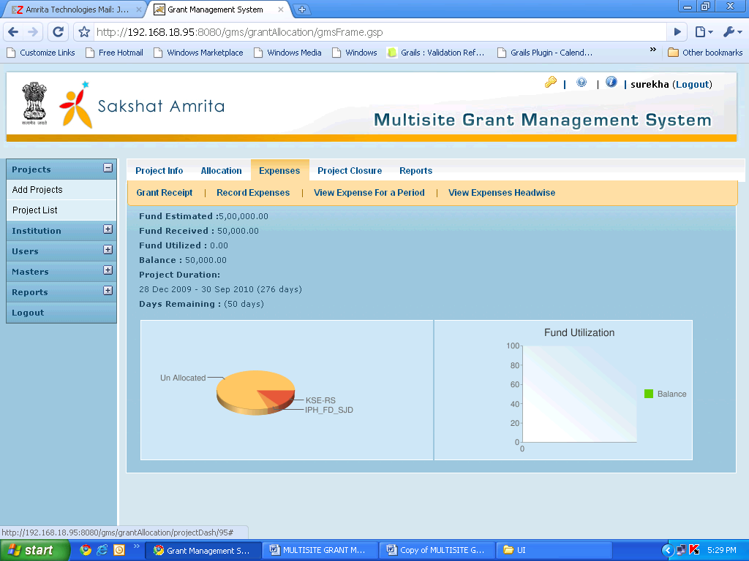
Click on Grant Receipt to Receive Grant Money

The transferred amount will be listed in the grant receipt screen of the grantee as shown below. Grantee can receive amount against the transferred fund or against grant allocation.

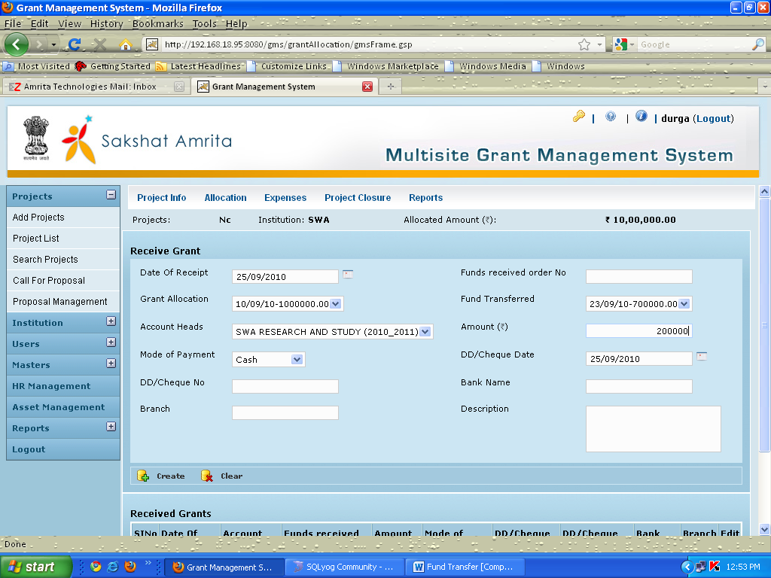
Click on Create to Receive Grant

Click on Create to Receive Grant

Below is the screen with message showing the Receipt of the Grant. Grant Receipt List showing all the Receipts

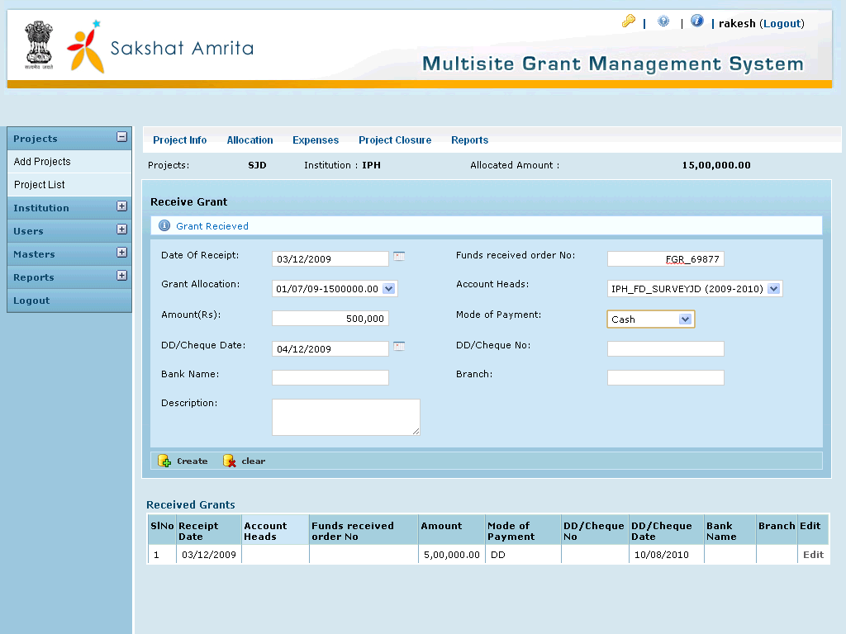

Please note that a Grant Receipt can be recorded only if the corresponding fund transfer has been recorded by the grantor. A Receipt can be recorded only against a specific fund transfer and that too, only once. The received amount will be the same as fund transferred and is not editable

